**Exercise 1: Mocking and Stubbing**

Scenario:

You need to test a service that depends on an external API. Use Mockito to mock the external API and stub its methods.

Steps:

1. Create a mock object for the external API.

2. Stub the methods to return predefined values.

3. Write a test case that uses the mock object.

**Solution-**

**Adding dependencies:**

<project xmlns="http://maven.apache.org/POM/4.0.0"

xmlns:xsi="http://www.w3.org/2001/XMLSchema-instance"

xsi:schemaLocation="http://maven.apache.org/POM/4.0.0 https://maven.apache.org/xsd/maven-4.0.0.xsd">

<modelVersion>4.0.0</modelVersion>

<groupId>in.cognizant</groupId>

<artifactId>MockitoExercises</artifactId>

<version>0.0.1-SNAPSHOT</version>

<dependencies>

<dependency>

<groupId>org.junit.jupiter</groupId>

<artifactId>junit-jupiter</artifactId>

<version>5.7.0</version>

<scope>test</scope>

</dependency>

<dependency>

<groupId>org.mockito</groupId>

<artifactId>mockito-core</artifactId>

<version>3.12.4</version>

<scope>test</scope>

</dependency>

</dependencies>

</project>

**1. External API Interface**

package in.cognizant;

public interface ExternalApi {

String getData();

}

**2. Methods to return predefined values**

package in.cognizant;

public class MyService {

private ExternalApi api;

public MyService(ExternalApi api) {

this.api = api;

}

public String fetchData() {

return api.getData();

}

}

**3. Test case that use mock object**

package in.cognizant;

import static org.junit.jupiter.api.Assertions.assertEquals;

import static org.mockito.Mockito.mock;

import static org.mockito.Mockito.when;

import org.junit.jupiter.api.Test;

public class MyServiceTest {

@Test

public void testExternalApi() {

ExternalApi mockApi = mock(ExternalApi.class);

when(mockApi.getData()).thenReturn("Mock Data");

MyService service = new MyService(mockApi);

String result = service.fetchData();

assertEquals("Mock Data", result);

}

}

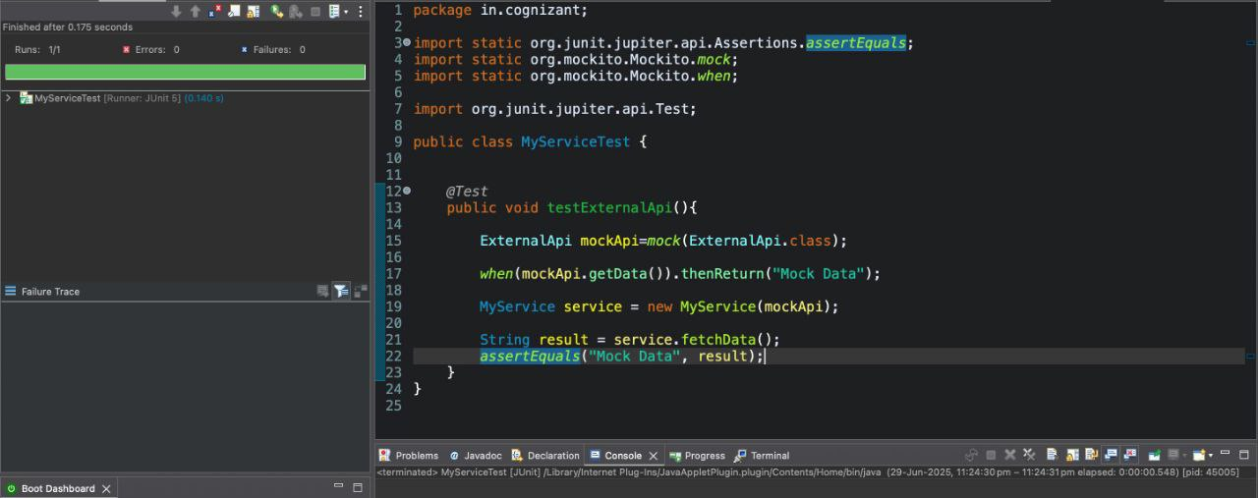**Output-**

**Exercise 2: Verifying Interactions**

Scenario:

You need to ensure that a method is called with specific arguments.

Steps:

1. Create a mock object.

2. Call the method with specific arguments.

3. Verify the interaction.

**Solution-**

**Adding dependencies:**

<project xmlns="http://maven.apache.org/POM/4.0.0"

xmlns:xsi="http://www.w3.org/2001/XMLSchema-instance"

xsi:schemaLocation="http://maven.apache.org/POM/4.0.0 https://maven.apache.org/xsd/maven-4.0.0.xsd">

<modelVersion>4.0.0</modelVersion>

<groupId>in.cognizant</groupId>

<artifactId>MockitoExercises</artifactId>

<version>0.0.1-SNAPSHOT</version>

<dependencies>

<dependency>

<groupId>org.junit.jupiter</groupId>

<artifactId>junit-jupiter</artifactId>

<version>5.7.0</version>

<scope>test</scope>

</dependency>

<dependency>

<groupId>org.mockito</groupId>

<artifactId>mockito-core</artifactId>

<version>3.12.4</version>

<scope>test</scope>

</dependency>

</dependencies>

</project>

**1. External API Interface**

package in.cognizant;

public interface ExternalApi {

String getData();

}

**2. Methods to return predefined values**

package in.cognizant;

public class MyService {

private ExternalApi api;

public MyService(ExternalApi api) {

this.api = api;

}

public String fetchData() {

return api.getData();

}

}

**3. Verify the interaction**

package in.cognizant;

import static org.mockito.Mockito.mock;

import static org.mockito.Mockito.verify;

import org.junit.jupiter.api.Test;

public class MyServiceTest {

@Test

public void testVerifyInteraction() {

ExternalApi mockApi = mock(ExternalApi.class);

MyService service = new MyService(mockApi);

service.fetchData();

verify(mockApi).getData();

}

}

**Output-**

